**Projet FULL BIM**

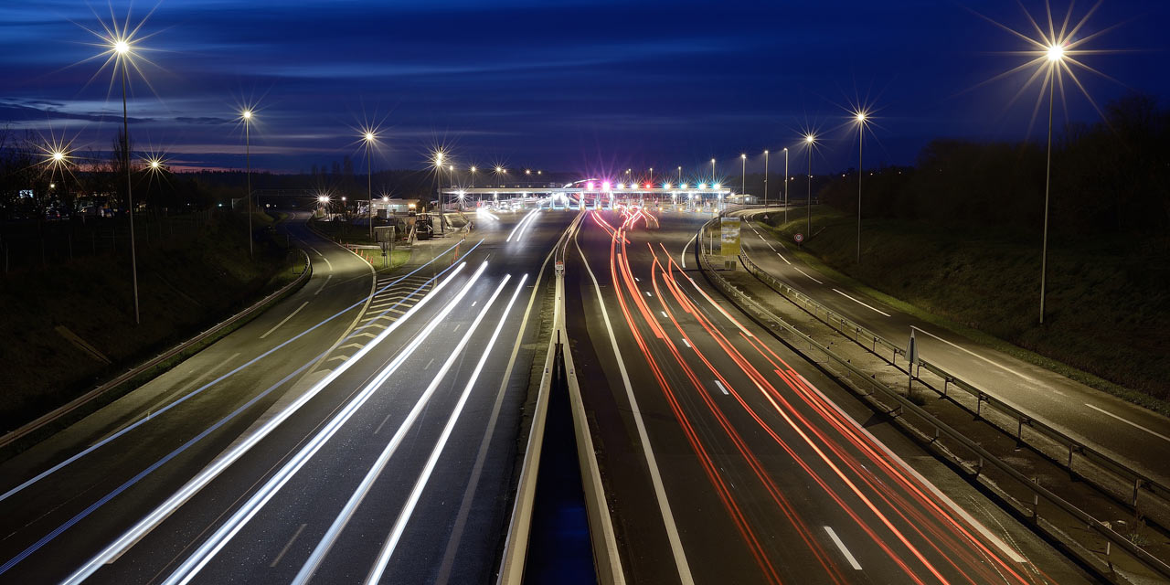

**Plan Assurance Qualité Technique**

Table des matières

No table of contents entries found.